

OSI Layer 2 Hacking Methods Lab
ADV. Cisco Periods 6-7
Sheen, ALen (Student)

Purpose
The primary objective of this lab is to explore and demonstrate vulnerabilities at the Data Link layer (Layer 2) of the OSI model. By executing a series of structured attacks on a configured network, the goal is to introduce performance degradation, cause instability, and interfere with normal communication flows. Through this process, we aim to gain a deeper understanding of both how these attacks are executed and the necessary countermeasures that can be implemented to defend against them.
Background Information on lab concepts
Layer 2, the Data Link Layer of the OSI (Open Systems Interconnection) model, is responsible for node-to-node data transfer within the same local area network (LAN). It plays a vital role in ensuring data integrity and reliable communication between directly connected devices. Key components of this layer include MAC (Media Access Control) addresses, ARP (Address Resolution Protocol) tables, and CAM (Content Addressable Memory) tables.
Switches are fundamental devices at Layer 2. They use MAC addresses to forward traffic efficiently by maintaining CAM tables that map MAC addresses to specific switch ports. Similarly, ARP tables allow the mapping of IP addresses to MAC addresses, enabling proper device communication within a subnet.
Due to the trust-based nature of Layer 2 protocols and the lack of authentication mechanisms, several types of attacks can be carried out on a network, including:
- MAC Flooding: Overloading a switch’s CAM table with fake MAC entries.
- DHCP Starvation: Exhausting the available DHCP address pool with fake requests.
- ARP Spoofing: Injecting fake ARP responses to intercept or reroute network traffic.
These attacks can degrade network performance, prevent devices from obtaining IP addresses, or even enable full-on Man-in-the-Middle (MitM) intrusions. Understanding these vulnerabilities and applying defensive configurations is critical in modern network administration.
MAC Attack
This attack exploits the limited amount of information that can stored in a CAM table. Switches build these MAC tables through flooding switchports when they don’t know where to send a packet. It then uses responses to build a CAM table that makes it more effective at its job. Through directing switches to send packets to MAC addresses that don’t exist in a network, you can fill up the CAM table. Using Dsniff (macof), you can generate over 480,000 MAC entries per second. This means it would take around 70 seconds to completely fill up a CAM table. Once the table is full, traffic without a CAM entry floods onto the VLAN, but not existing traffic with an existing CAM entry. Once the CAM table is full, switches will begin to flood switchports will traffic in hopes of reaching the correct destination. You can intercept this traffic with a tool like Wireshark, ultimately hacking into a network to obtain sensitive information.
DHCP Starvation
The objective of this attack is to create bogus discover packets so that the DHCP pool on a network does not have any addresses for actual devices to communicate. Dynamic host Configuration Protocol is responsible for automatically assigning addresses to devices. These are configured with a limited pool, so when that pool uses all the addresses, the network cannot assign new devices' addresses, making it unusable. To prevent this attack from happening, you can limit the number of addresses given out to certain things, allowing for addresses to still be available for actual devices to use.
ARP Spoofing
Devices will send fake ARP messages to associate with the MAC addresses of devices, and the network will assign these malicious ARP messages to correct MAC addresses, limiting communication and the amount of traffic that will be successfully delivered. To prevent these attacks, you can have static ARP addresses, which is useful for small addresses or initiate switchport security to overcome this attack.
Lab Summary
This lab successfully demonstrated how easily Layer 2 networks can be disrupted when proper security measures are not in place. Through MAC flooding, DHCP starvation, and ARP spoofing, we saw firsthand how performance and functionality can be impacted. More importantly, we learned how to configure Layer 2 security features on switches to counteract these threats. The experience reinforced the importance of proactive security in network design, especially at the foundational Layer 2 level. A secure network begins with understanding its vulnerabilities and actively applying configurations to protect against them.
Lab Commands
Setup network
1. On the router, configure an IP address for connectivity and configure a DHCP server to distribute IP addresses.
2. Connect both the attacker and victim to the network and ensure that they can receive IP addresses.
DHCP Starvation Attack
1. On the attacker, install Yersinia sudo apt install yersinia
2. Disconnect the victim and attacker from the switch, and release all DHCP bindings on the router clear ip dhcp bindings *
3. Reconnect the attacker to gain an IP address through DHCP.
4. On the attacker, run the DHCP Discover flood attack.
a. Bring up the Yersinia GUI sudo yersinia -G
b. Click “Launch Attack” and select the DHCP Discover flood attack
5. On the router, show DHCP bindings to demonstrate the attack. show ip dhcp pool
6. Connect the victim to the network. Note that the PC is unable to receive an IP address.
7. To reset the network, clear DHCP bindings again. clear ip dhcp bindings *
DHCP Starvation Prevention
On the switch, enable port-security on all untrusted ports and set a maximum of 2 MAC addresses along with the following configurations.
switchport mode access switchport port-security switchport port-security maximum 2 switchport port-security violation restrict switchport port-security mac-address sticky
ARP Spoofing Attack
In an ARP spoofing attack, the attacker sends falsified ARP replies that associate their MAC address with the IP address of a legitimate network device (such as the gateway). As a result, traffic intended for the real device is sent to the attacker, enabling interception or modification of the data.
Defense:
ARP spoofing can be prevented by enabling dynamic ARP inspection (DAI) and DHCP snooping on the switch. These features validate ARP packets and block malicious activity. The router’s port should be marked as trusted.
Bash

ip dhcp snooping
ip dhcp snooping vlan 1
ip arp inspection vlan 1

interface FastEthernet0/1
ip dhcp snooping trust
ip arp inspection trust
MAC Flooding Prevention
On the switch, enable port-security on all untrusted ports and set a maximum of 1 MAC address along with the following configurations.
switchport mode access
switchport port-security
switchport port-security maximum 1
switchport port-security violation restrict
switchport port-security mac-address sticky

Network Diagram with IP’s
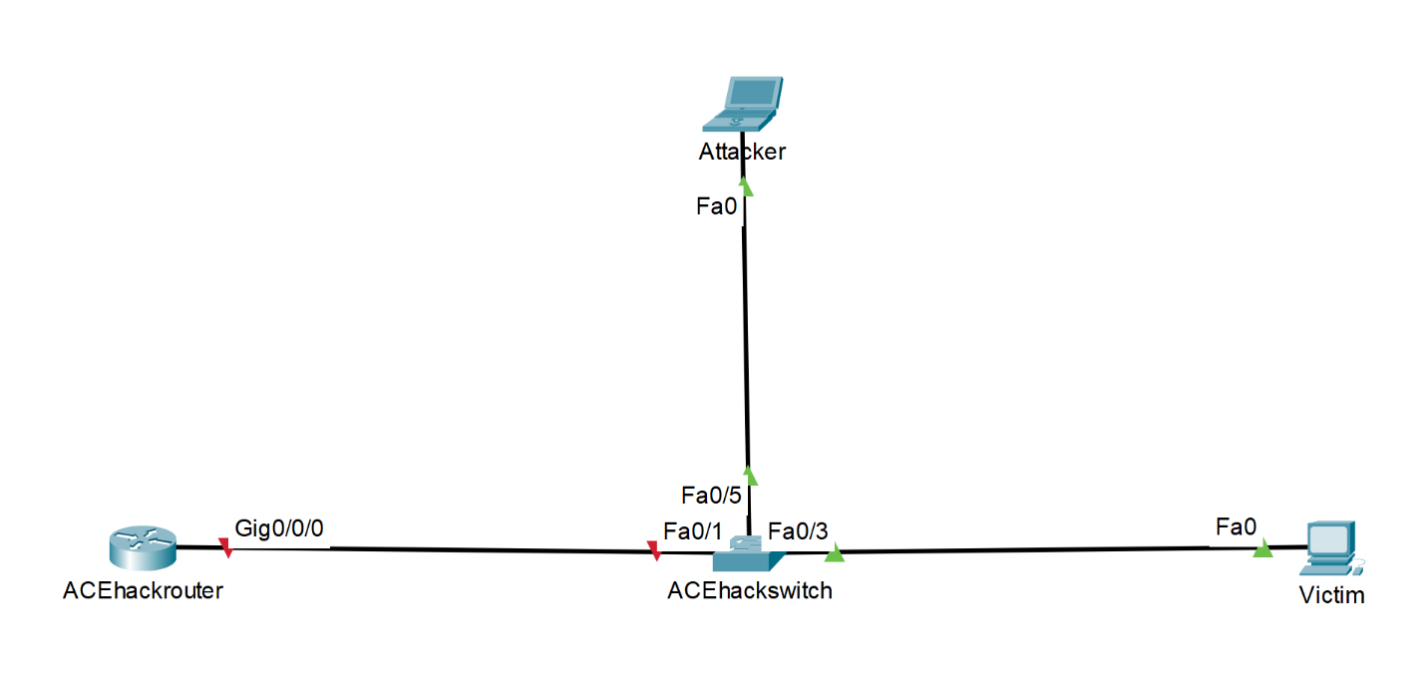

Configurations Show run on all routes involved
ACEhackswitch
version 12.2
no service pad
service timestamps debug datetime msec
service timestamps log datetime msec
no service password-encryption
hostname ACEhackswitch
boot-start-marker
boot-end-marker
no aaa new-model
system mtu routing 1500
authentication mac-move permit
ip subnet-zero
ip dhcp snooping vlan 1
ip dhcp snooping
ip arp inspection vlan 1
spanning-tree mode pvst
spanning-tree etherchannel guard misconfig
spanning-tree extend system-id
vlan internal allocation policy ascending
interface FastEthernet0/1
ip arp inspection trust
spanning-tree portfast
ip dhcp snooping trust
interface FastEthernet0/2
interface FastEthernet0/3
interface FastEthernet0/4
interface FastEthernet0/5
switchport mode access
switchport port-security
switchport port-security violation restrict
switchport port-security mac-address sticky
switchport port-security mac-address sticky 5091.e368.6297 vlan access
spanning-tree portfast
interface FastEthernet0/6
interface FastEthernet0/7
interface FastEthernet0/8
interface FastEthernet0/9
interface FastEthernet0/10
interface FastEthernet0/11
interface FastEthernet0/12
interface FastEthernet0/13
interface FastEthernet0/14
interface FastEthernet0/15
interface FastEthernet0/16
interface FastEthernet0/17
interface FastEthernet0/18
interface FastEthernet0/19
interface FastEthernet0/20
interface FastEthernet0/21
interface FastEthernet0/22
interface FastEthernet0/23
interface FastEthernet0/24
interface GigabitEthernet0/1
interface GigabitEthernet0/2
interface Vlan1
no ip address
ip classless
ip http server
ip http secure-server
ip sla enable reaction-alerts
line con 0
line vty 5 15
end

ACEhackrouter
version 16.9
service timestamps debug datetime msec
service timestamps log datetime msec
platform qfp utilization monitor load 80
platform punt-keepalive disable-kernel-core
hostname ACEhackrouter
boot-start-marker
boot-end-marker
vrf definition Mgmt-intf
address-family ipv4
exit-address-family
address-family ipv6
exit-address-family
no aaa new-model
ip dhcp excluded-address 192.168.0.0 192.168.0.9
ip dhcp pool SERVER
network 192.168.0.0 255.255.255.0
dns-server 8.8.8.8
default-router 192.168.0.1
login on-success log
subscriber templating
vtp domain cisco
vtp mode transparent
multilink bundle-name authenticated
license udi pid ISR4321/K9 sn FDO21281AAT
no license smart enable
diagnostic bootup level minimal
spanning-tree extend system-id
redundancy
mode none
interface GigabitEthernet0/0/0
ip address 192.168.0.1 255.255.255.0
negotiation auto
interface GigabitEthernet0/0/1
no ip address
negotiation auto
interface GigabitEthernet0/1/0
no ip address
shutdown
negotiation auto
interface GigabitEthernet0/1/1
no ip address
shutdown
negotiation auto
interface Service-Engine0/2/0
no ip address
interface GigabitEthernet0
vrf forwarding Mgmt-intf
no ip address
shutdown
negotiation auto
ip forward-protocol nd
ip http server
ip http authentication local
ip http secure-server
ip tftp source-interface GigabitEthernet0
control-plane
line con 0
transport input none
stopbits 1
line aux 0
stopbits 1
line vty 0 4
login
end

Problems
At the beginning of the lab, one of the main challenges I encountered was adapting to the Linux operating system. Unlike tools such as PuTTY, which we’ve used in previous labs with a more familiar interface, Linux required a different set of commands and a deeper understanding of the terminal environment. This created an initial learning curve in executing the necessary attack scripts and configurations. However, through practice and guidance, I was able to navigate the Linux environment more confidently and successfully carry out the Layer 2 attacks. This experience expanded my technical skillset and made me more versatile in working across different operating systems in networking contexts.
Conclusion
This lab provided a valuable and practical learning experience in both offensive and defensive network security at the Data Link layer. One of the most insightful aspects was understanding how access points and switches can be configured and exploited, which has many real-world applications. It was eye-opening to see how common networking equipment like switches, routers, and DHCP servers can become serious vulnerabilities if not properly secured. Since these devices are used everywhere from schools to businesses and even at home, knowing how to identify and prevent Layer 2 attacks is a crucial skill for anyone pursuing a career in IT, cybersecurity, or network engineering. This lab helped reinforce the importance of responsible network design and the proactive steps required to maintain a secure and stable environment.
Teacher Signoff Page of Lab Complete
